TOPIC- RESTAURANT

In the partial fulfilment of the bachelors in the technology computer science

2022-2026



SUBMITTED TO: - Mrs. Aashima

Remark: -

Signature: -

SUBMITTED BY: -

|  |  |  |  |
| --- | --- | --- | --- |
| NAME | ROLL NO. | UMS ID | YEAR |
| Bodicharla Naveen Kumar | 53 | 12217525 | 2022-2026 |

**TABLE OF CONTENT**

**TITLE PAGES**

STUDENT DECLARATION

ABSTRACT

ACKNOWLEDGEMENT

OBJECTIVE

INTRODUCTION

ABOUT US

CSS

CONCLUSION

REFERENCE

**STUDENT DECLARATION**

This is to declare that this report only done by single student Naveen kumar. No part of this project is copied from the other sources. All the information included from other sources have been duly acknowledged. We ensure that if any part of the report is found to be copied, we shall take the full responsibility for it

Signature: Bodicharla Naveen Kumar

Roll no:53

Place: Lovely Professional University

Date : 28 December, 2022

**ABSTRACT**

This is an introduction page of our site **Eatz.**

**Eatz** is a restaurant site in which customer can know about the restaurant and its features.

The name of the web page is quite simple to what it’s going to provide.

The work of the web page is simple that customer can see the menu and order the food before they come to the restaurant

The web page is simple to use which means it is a user-friendly and easy to understand the working of the site.

**TECHNOLOGIES USED**

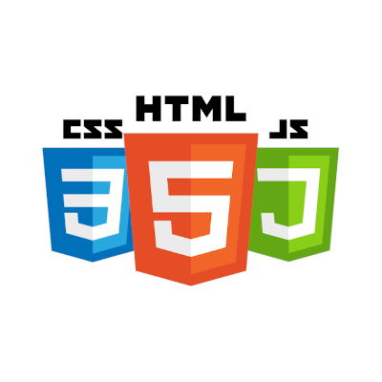

* HTML (MAX USE)
* CSS (Max USE)
* JAVASCRIPT (AT SOME POINT)

**HTML-**It is a markup language which is used to make the structure of the webpage.it stand for Hypertext markup language.

**CSS-**It is used for designing the web page.CSS gives the web page the look by which it looks attractive, and more people love the site. The full form of CSS is Cascading style sheets.

**JavaScript-**It is used for giving a brain to the site to function in a particular manner by which site can react according to user need and want.

We need more thing more languages to make the fully working site. But the combination of these three languages also helps us to make the good responsive web page. The working of the html, CSS and JavaScript is very simple to understand for example -html is the skeleton of the web page and CSS is the muscles, veins, skin of the body and JavaScript is the brain of the body which response the according to the situation.

**ACKNOWLEDGEMENT**

We would like to express our heartfelt gratitude to Mrs. Aashima mam for giving us the opportunity to work under her guidance and help us gain immensely enriching professional experience.

**OBJECTIVE OF THE PROJECT**

The objective of the making this project is that the customer who is going to visit our restaurant can get information of all type of the food and services which the restaurant is going to provide by which customer can know where he is going to visit.

The side also provide the feed back form by which the restaurant can improve the wrong part of the restaurant and make the environment of the restaurant more friendly to the user.

The side also have navigation bar by which it can guide the user that what other things restaurant provide to the customers

The goal is to provide an effective and efficient platform to make the

Decided whether you must go to the selected restaurant or not.

The way is very simple is it for every restaurant who wants to go online but have no idea to how to do so .

**INTRODUCTION**

* The start interface is very simple that every user can define the things by their own
* The starting part of the web page is start with the logo of the name of the restaurant and name of the restaurant
* After the logo part the navigation part arises by which user can navigate the more related pages of the restaurant webpage
* After the navigation part there is other navigation part where the user or customer can see the menu of the restaurant that what type of food is restaurant is going to provide
* In the menu navigation bar, there are food categories like north, south, chicken, Chinese and special offer
* There is the small gallery in the home page where user can see the type of food provided by the restaurant in the photo form there is the navigation bar of the gallery of the foods
* In the home page there is the part where user can see the speciality of the restaurant that what make this unique from the other restaurant
* The best part of the side it also provides the health tips to user
* There is the also feed back form where user can give the feedback to the restaurant what things they like and the things that don’t like in the restaurant by which restaurant can change the wrong thing into the good one and make the place user friendly

**SCREENSHOTS**

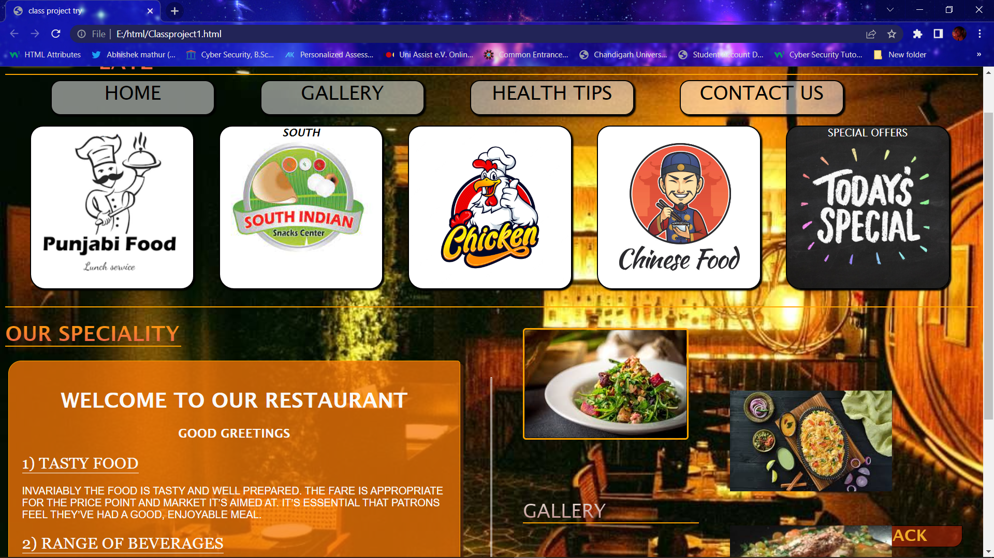

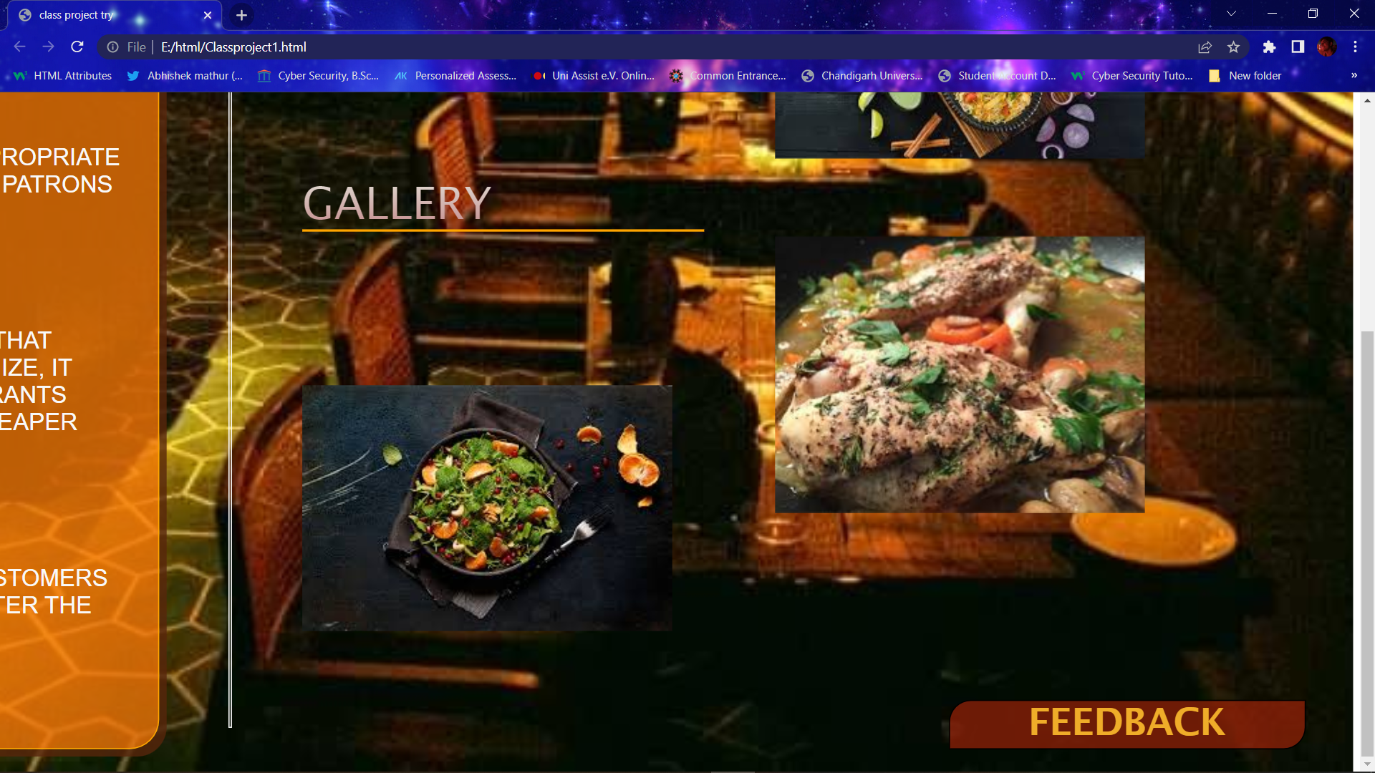

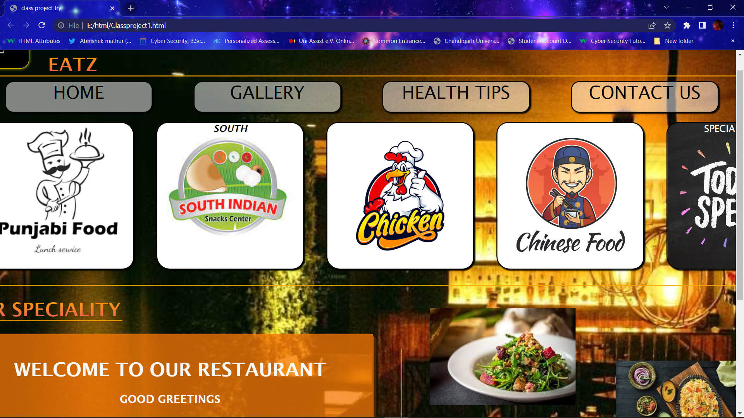

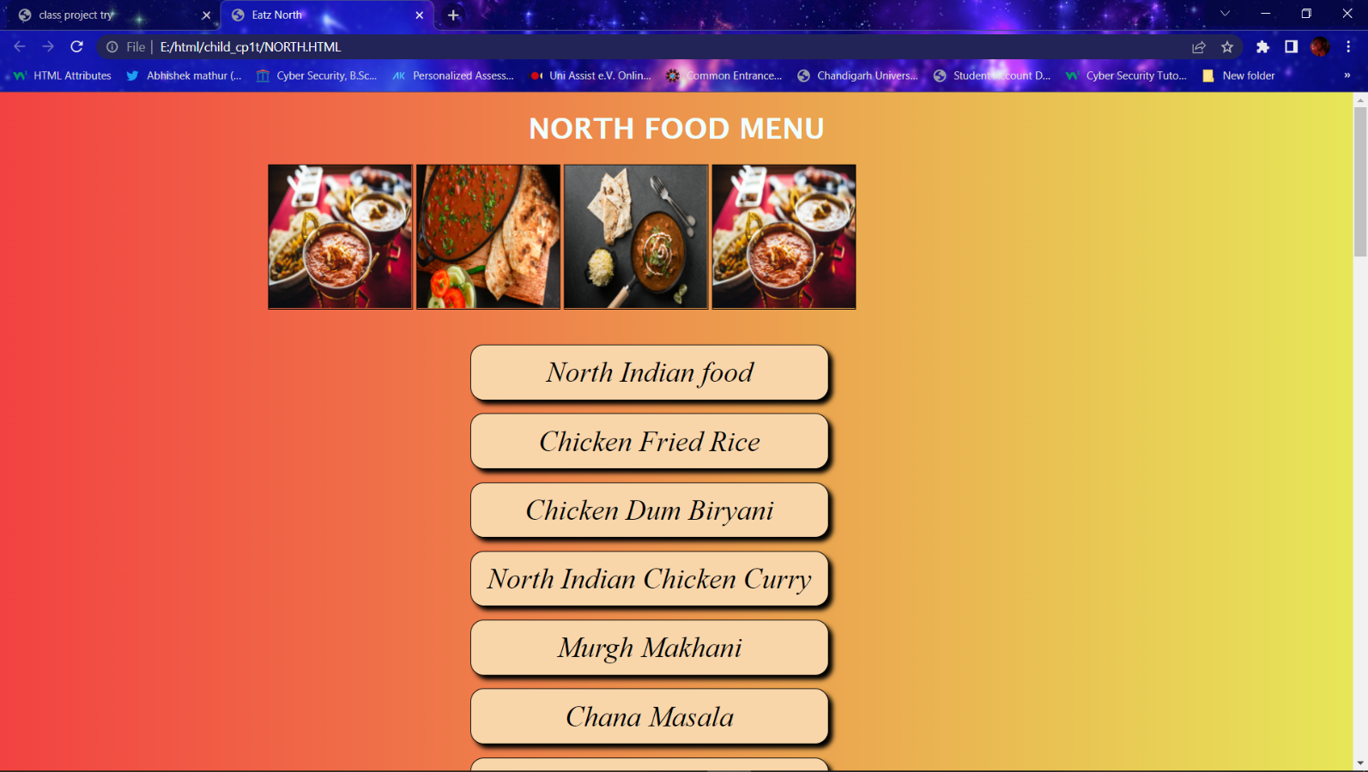

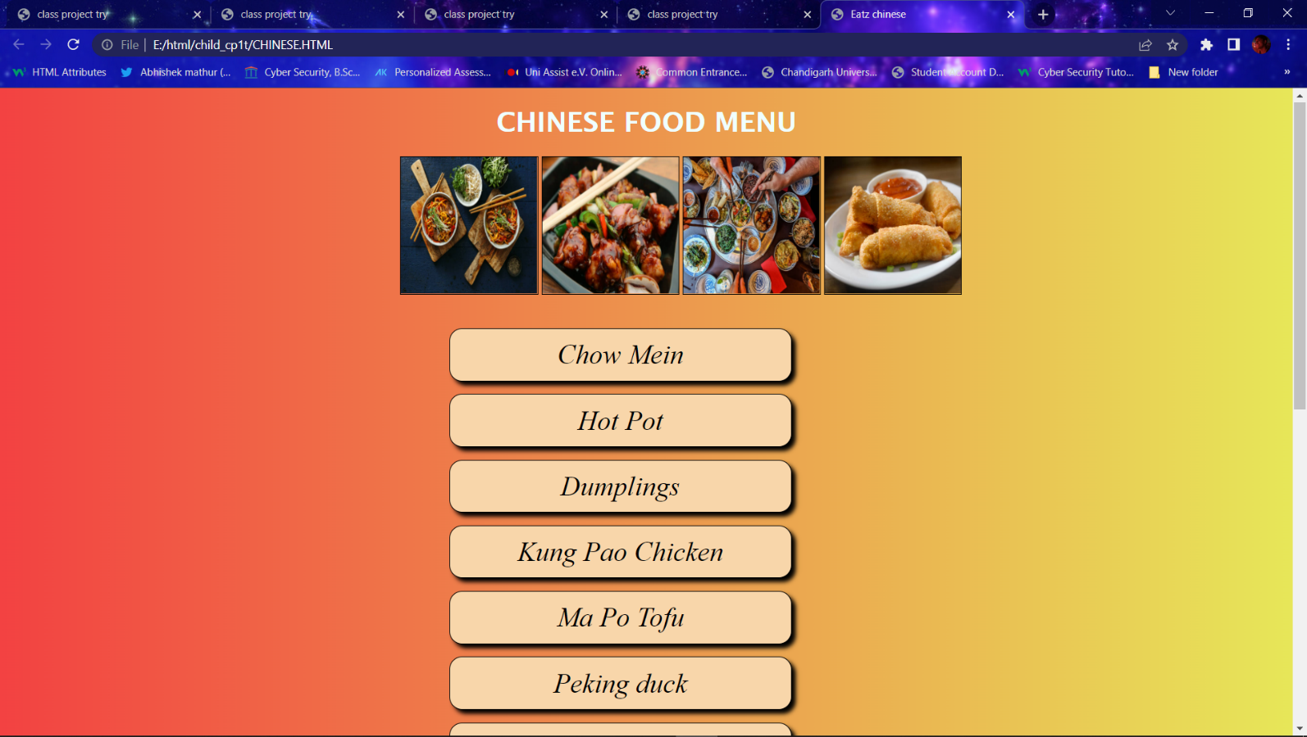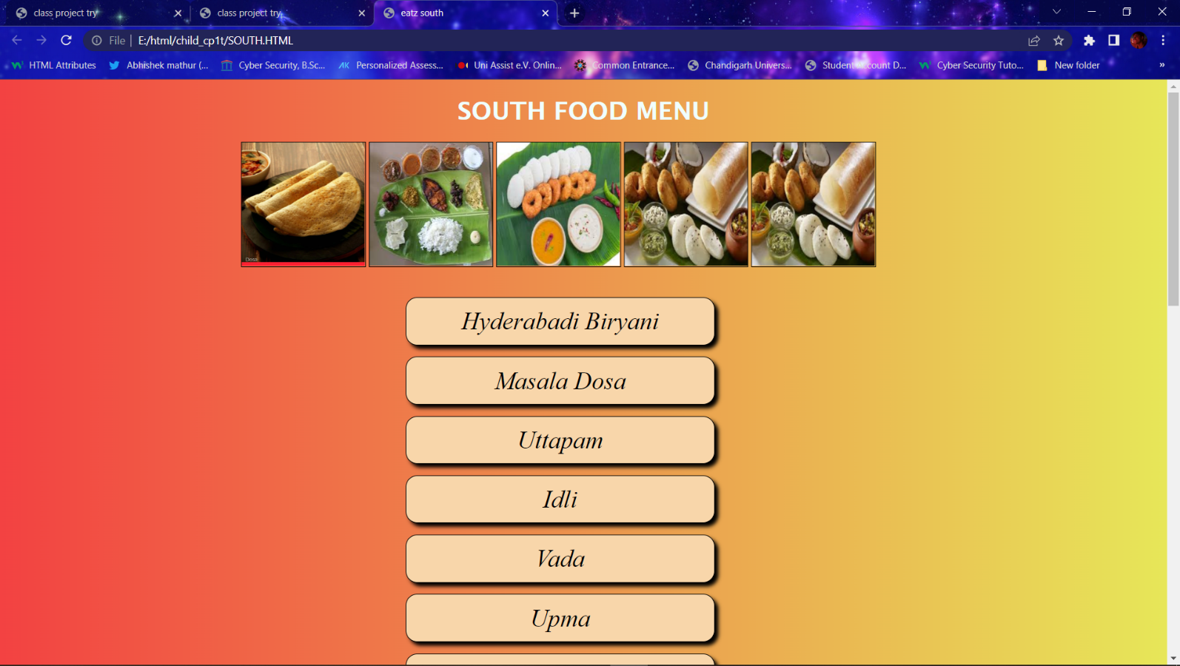

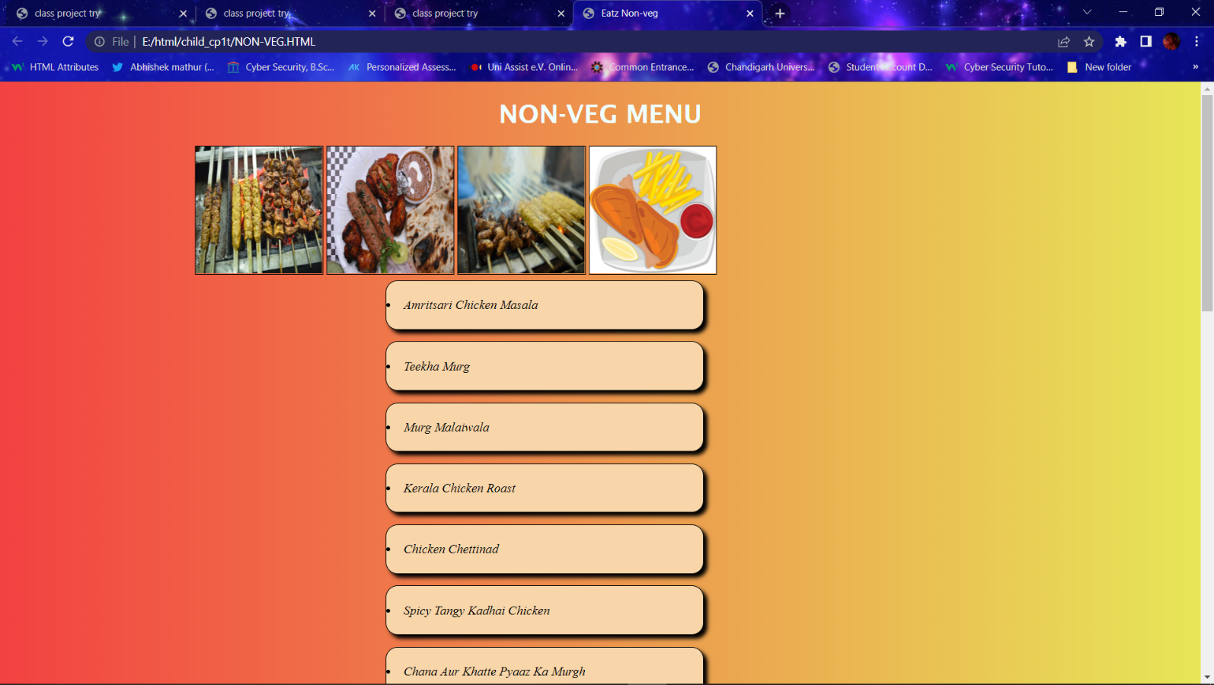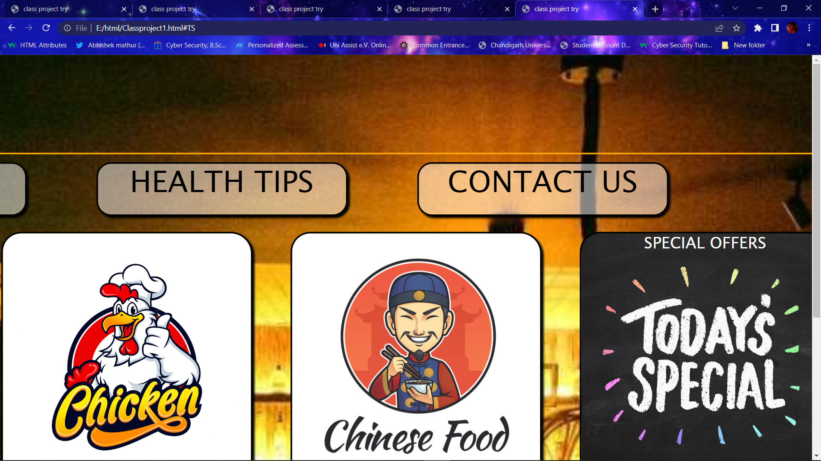

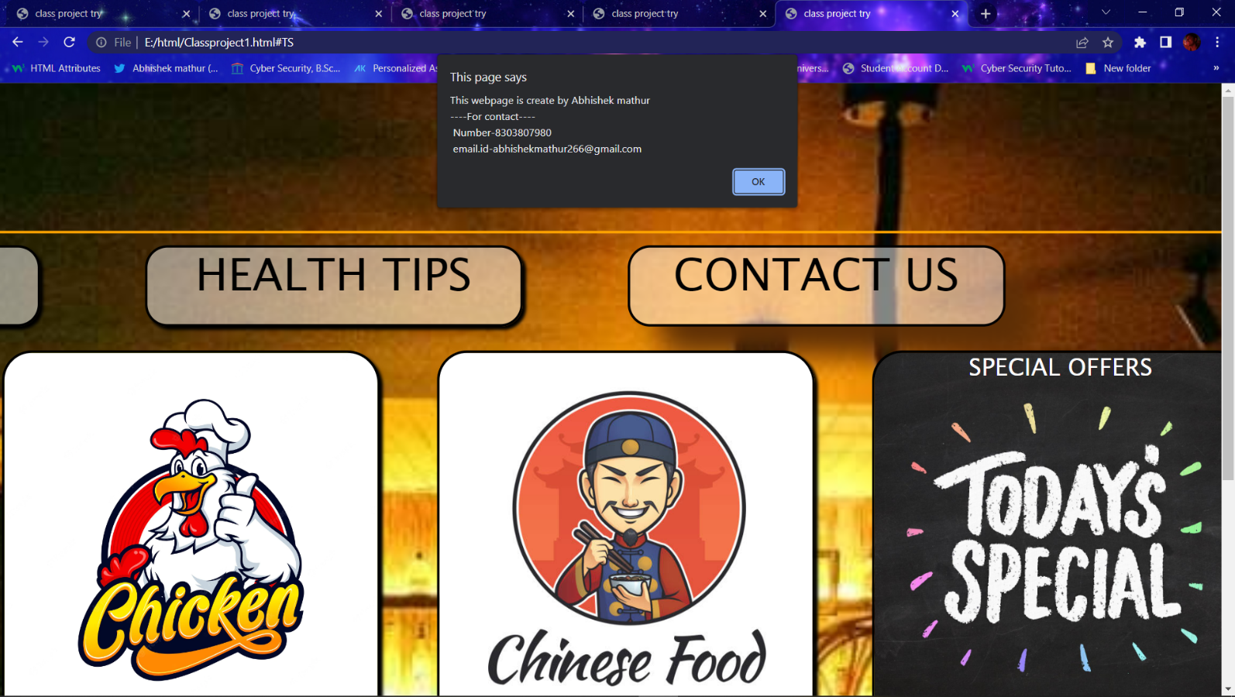

**Screenshots code:**

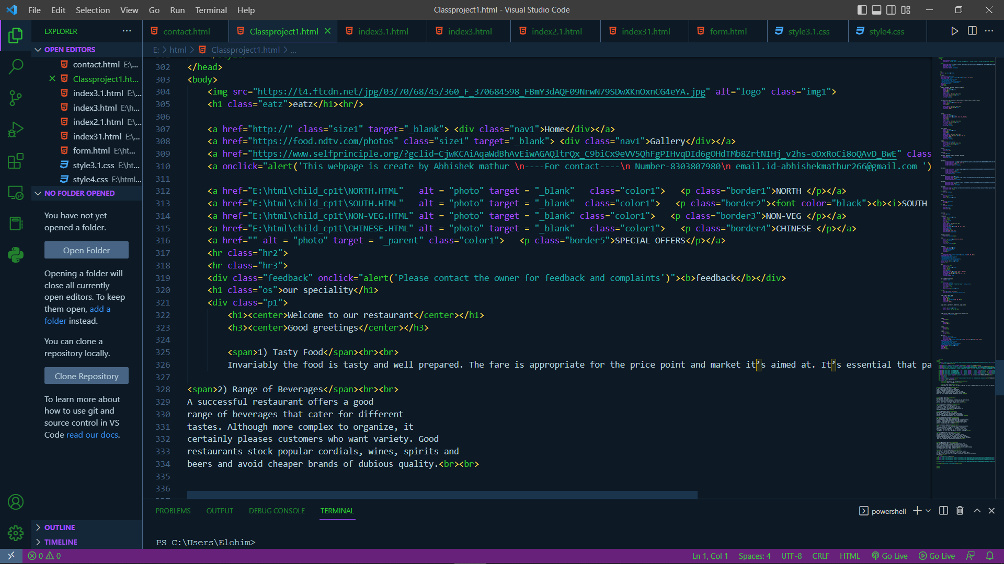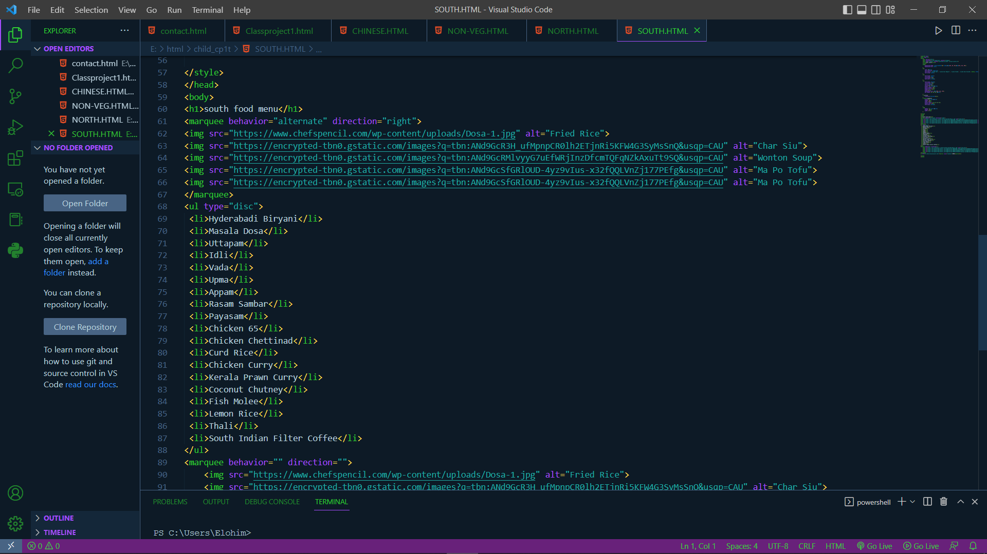

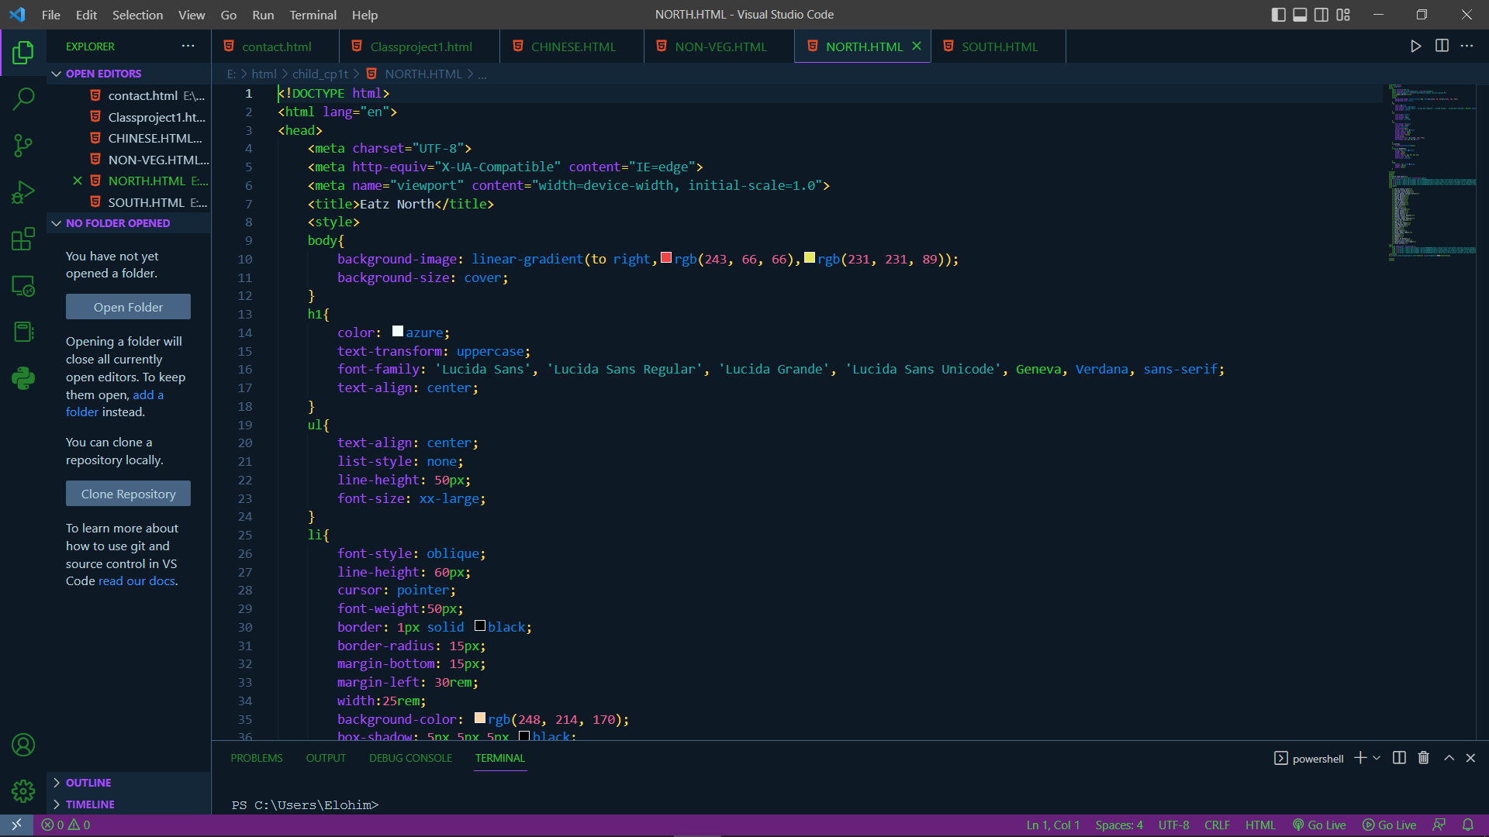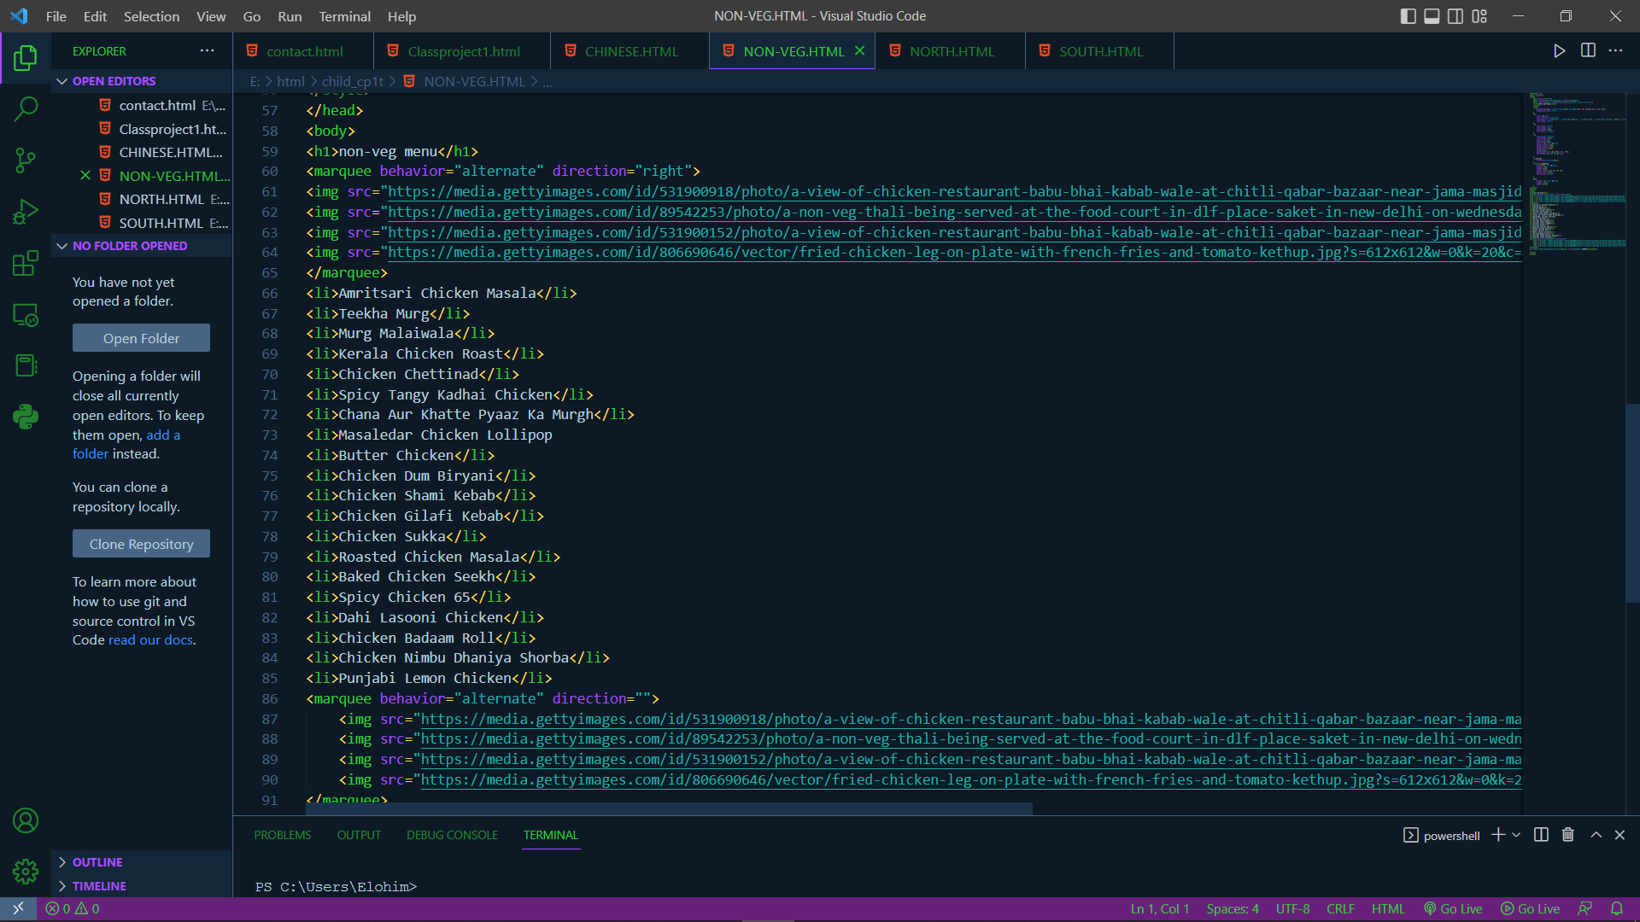

Css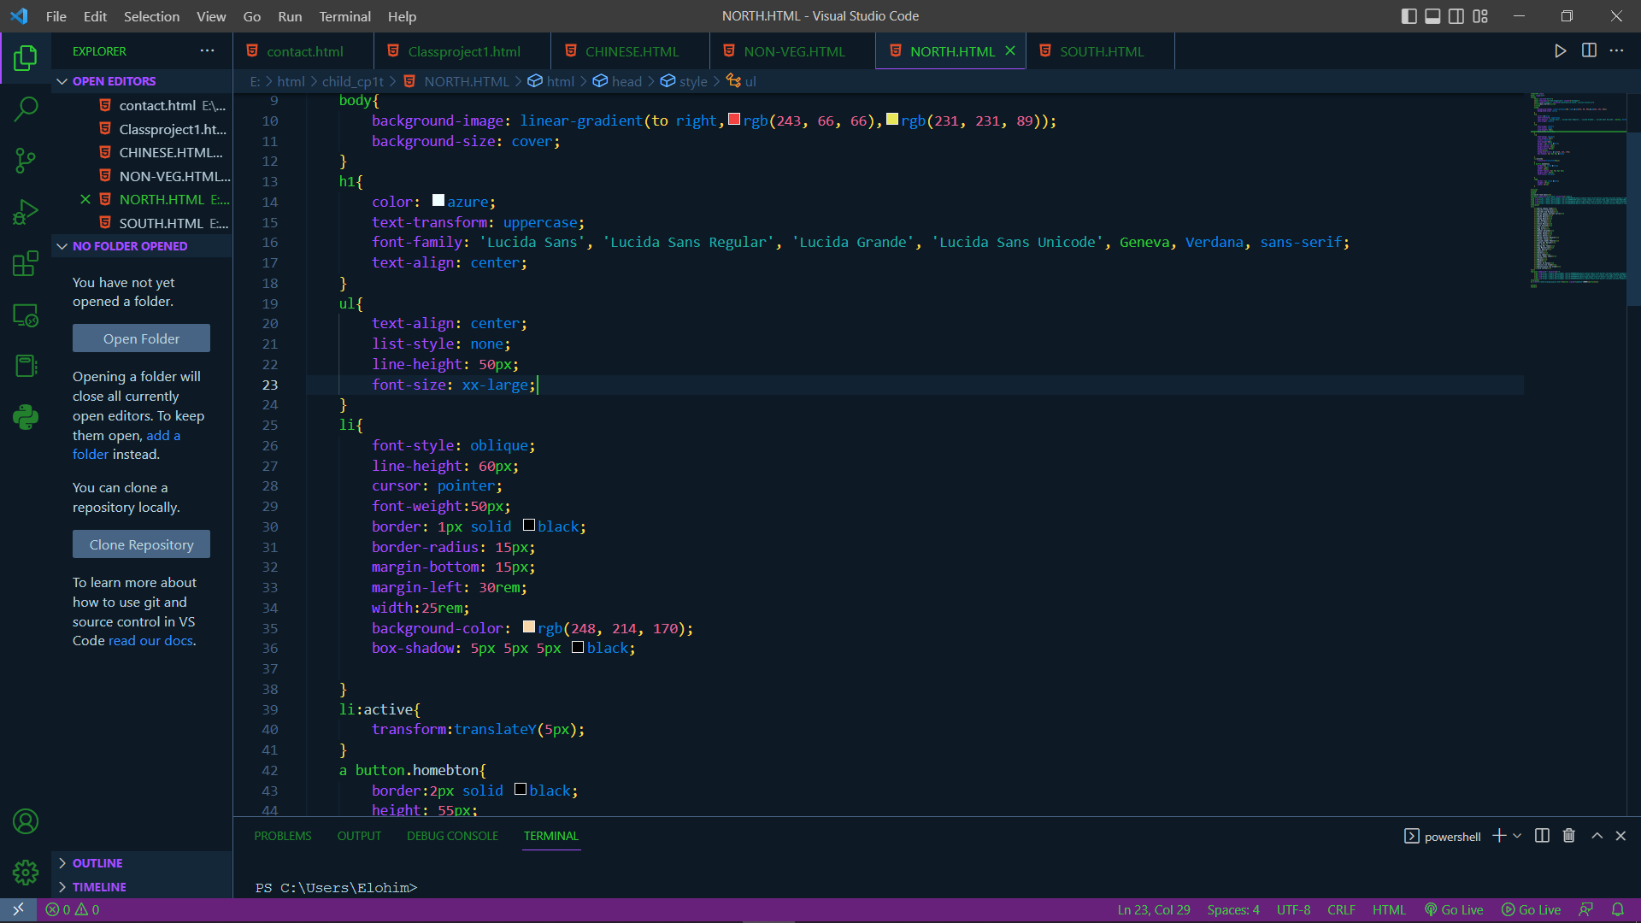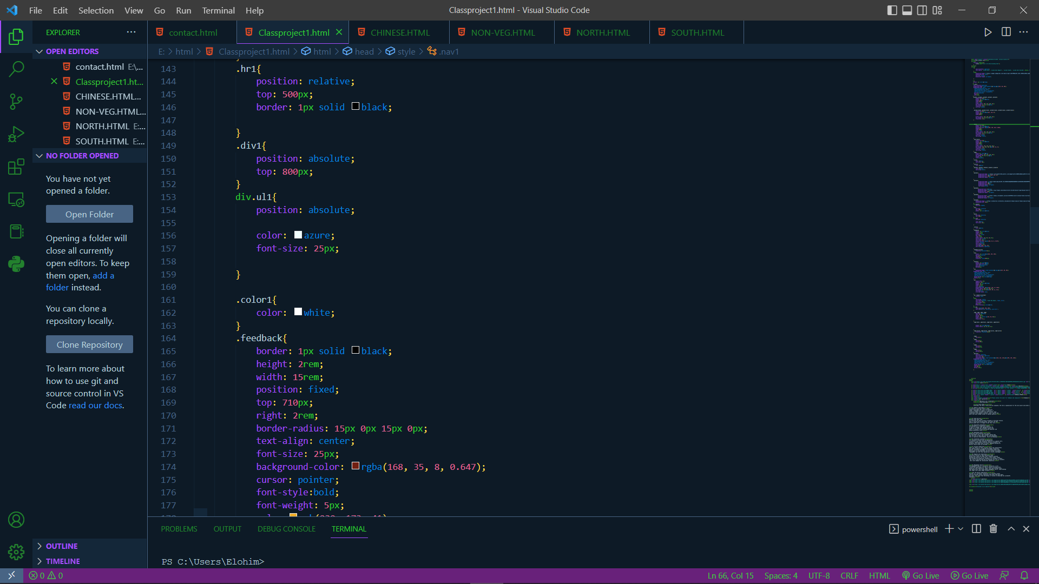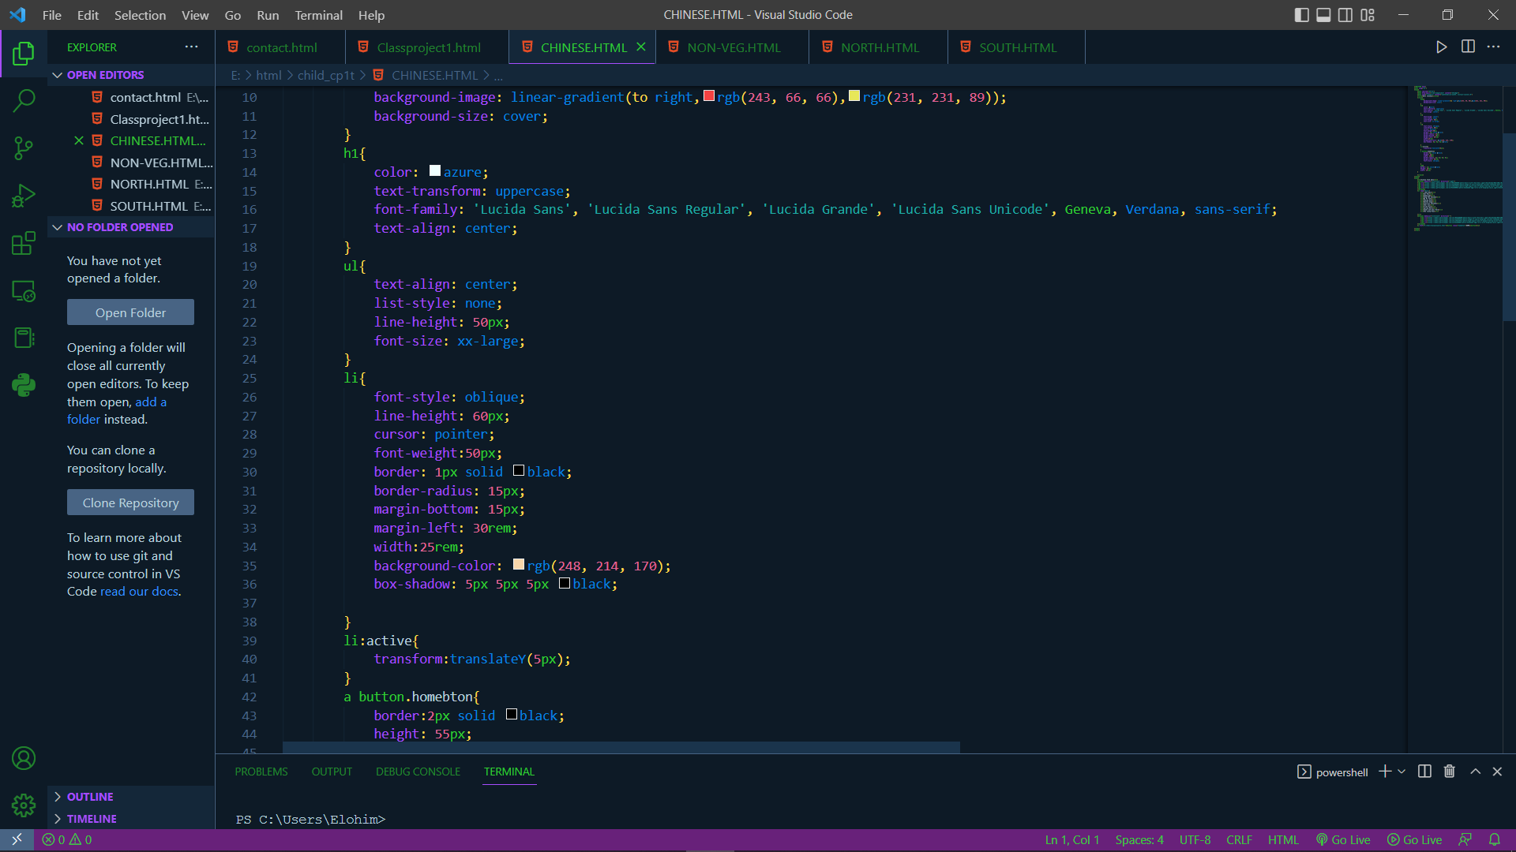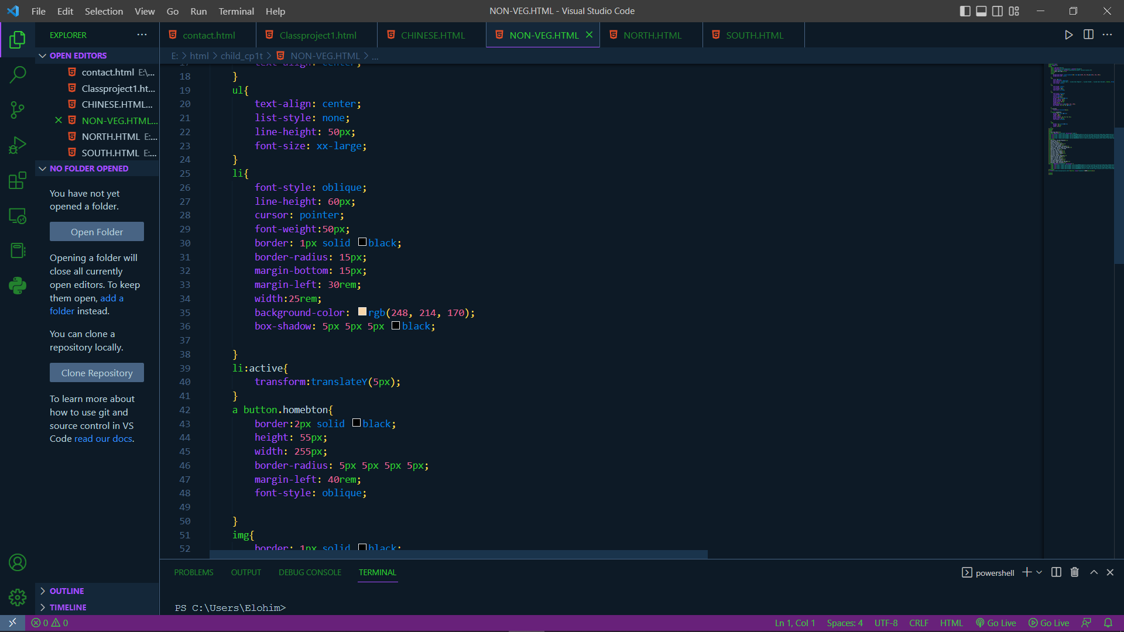

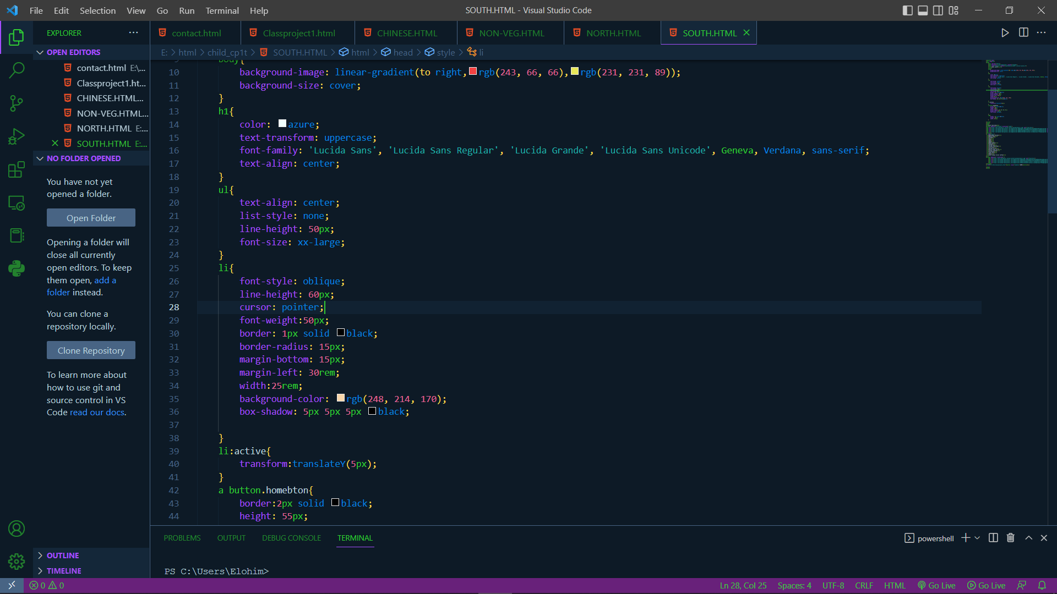

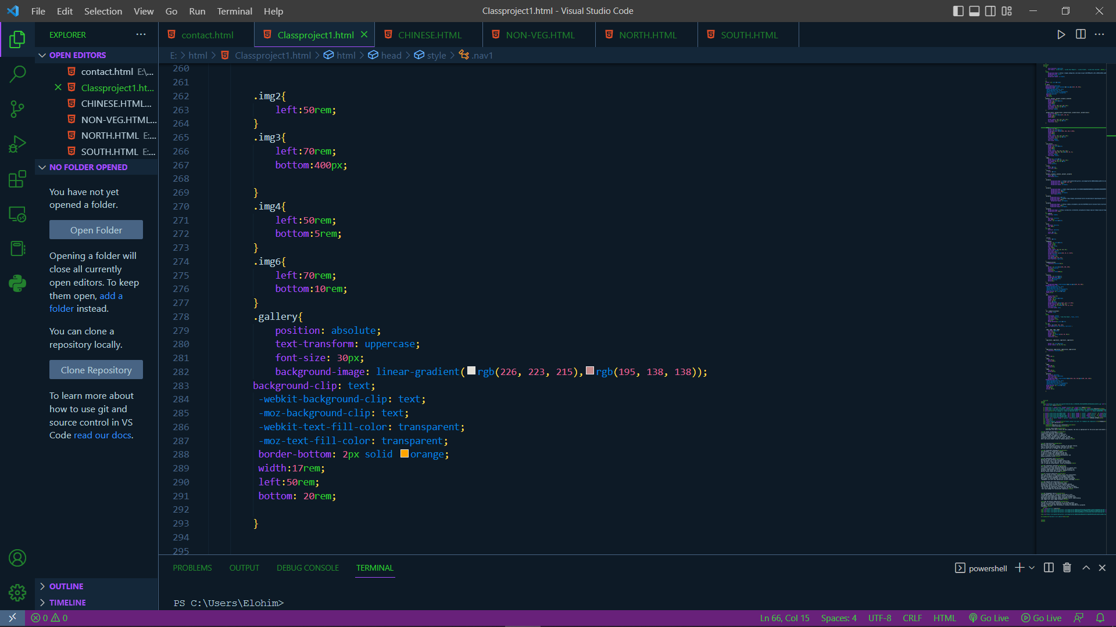

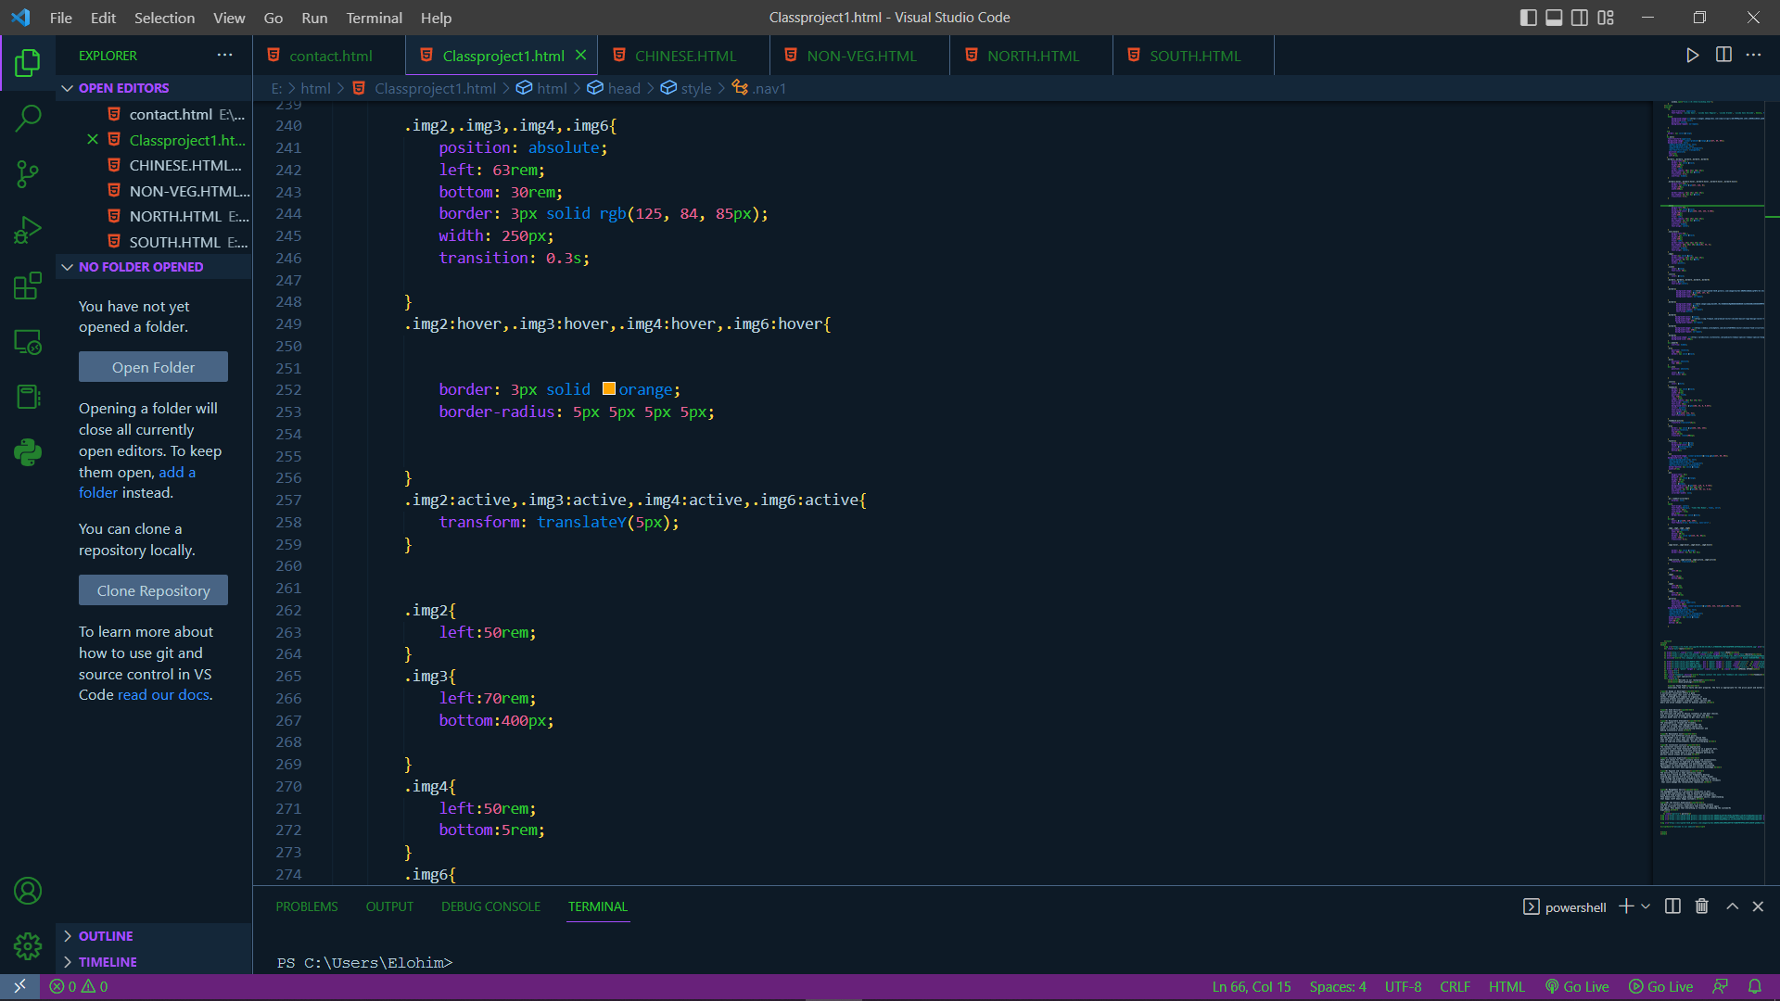

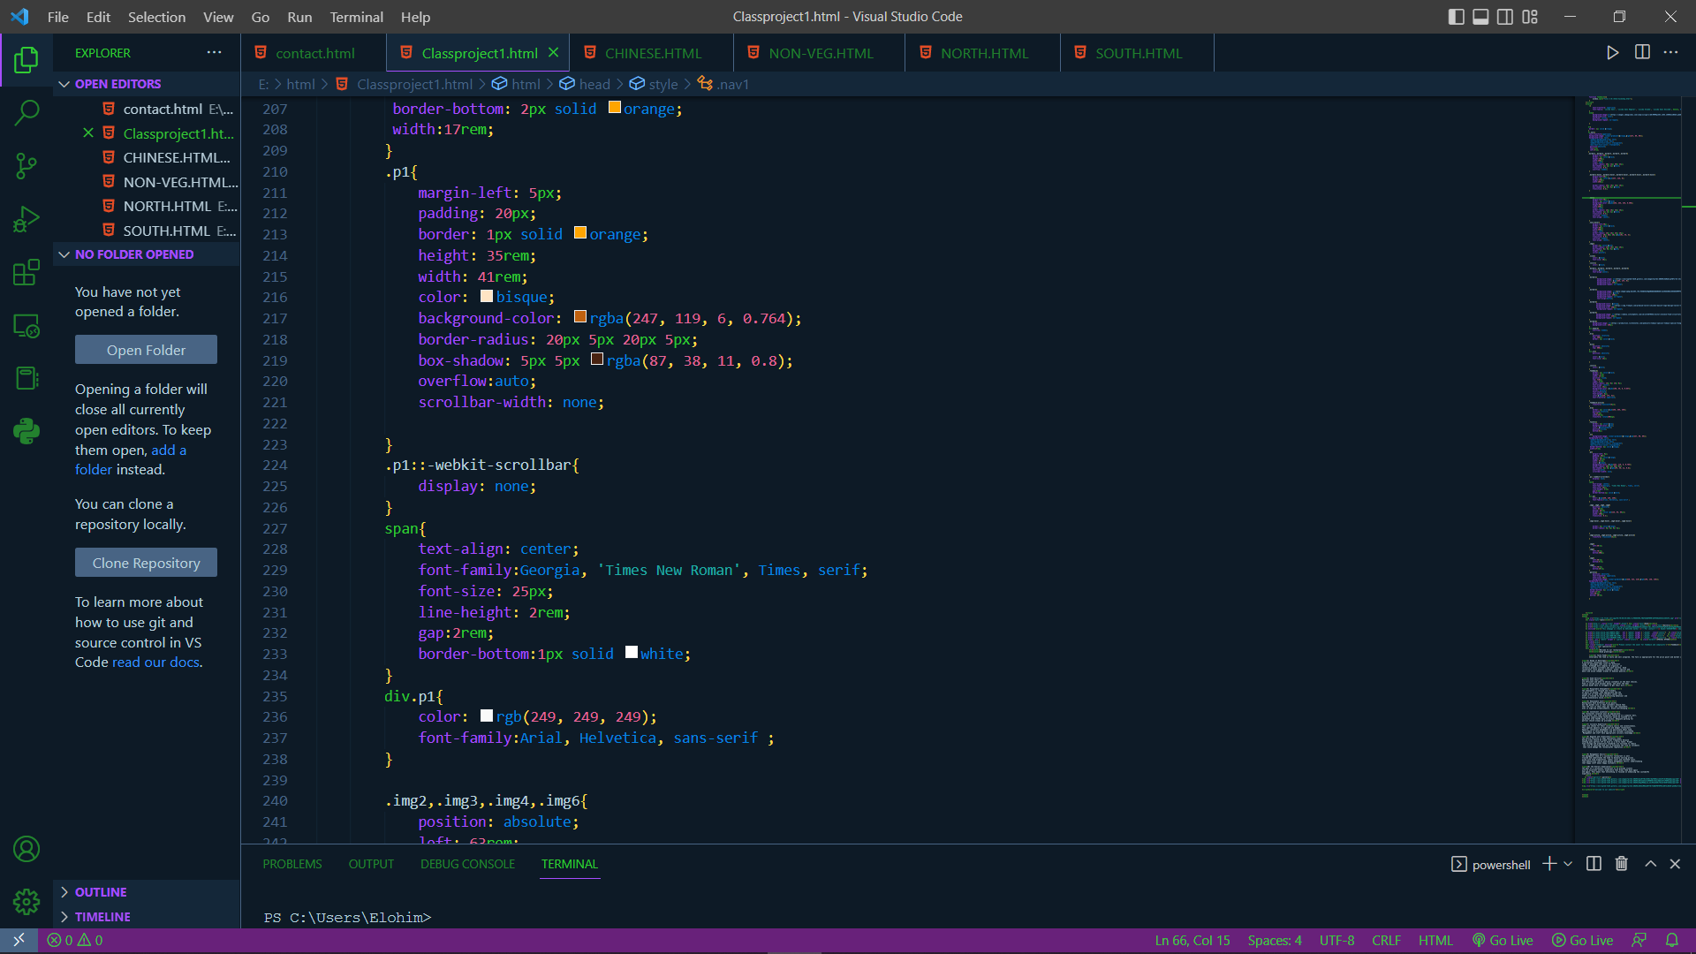

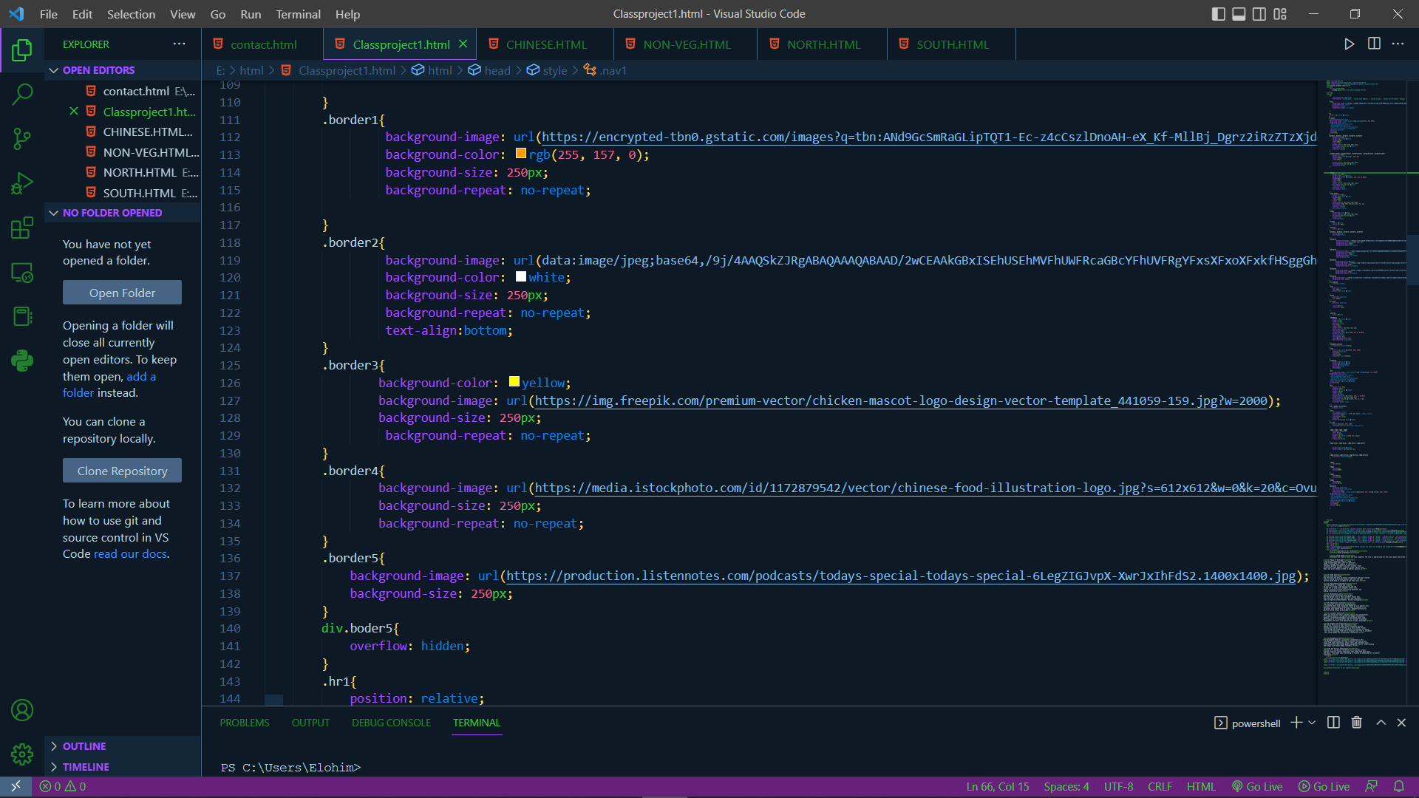

**CONCLUSION**

This project is the great opportunity to those restaurants who want to start the restaurant and want to take it online the format of the webpage is so simple by which they can take the idea of the side to make their own. This also help the user of the side to take the quick idea that where he is going to spend their hour. This side is also help to the user to go see the food and other things before they are ging t visit the place if there is an false information they can give the feed back .

**REFERENCE**

1. [www.w3cschool.com](http://www.w3cschool.com)
2. [www.google.com](http://www.google.com)
3. Book -Mastering HTML, CSS& JavaScript
4. Teacher’s help
5. Own idea